Step by step Procedure for Online Payment (Water Supply and Sewerage PHE Department):
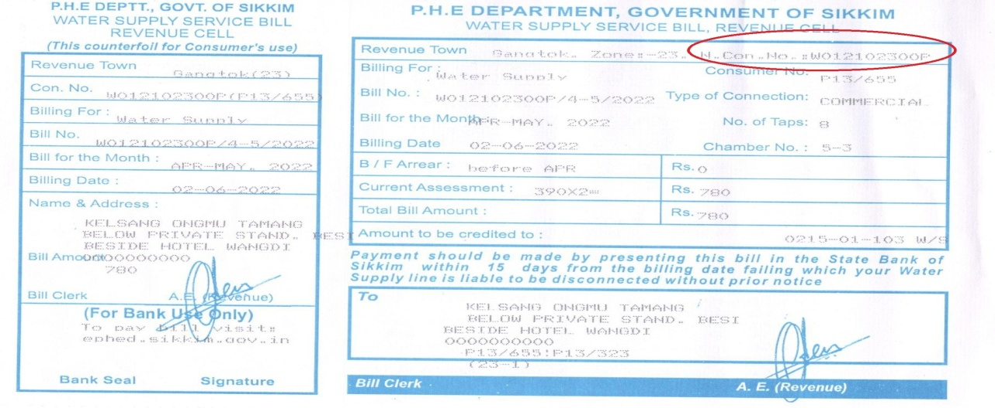
- Click on Online Payment

- This Page will appear
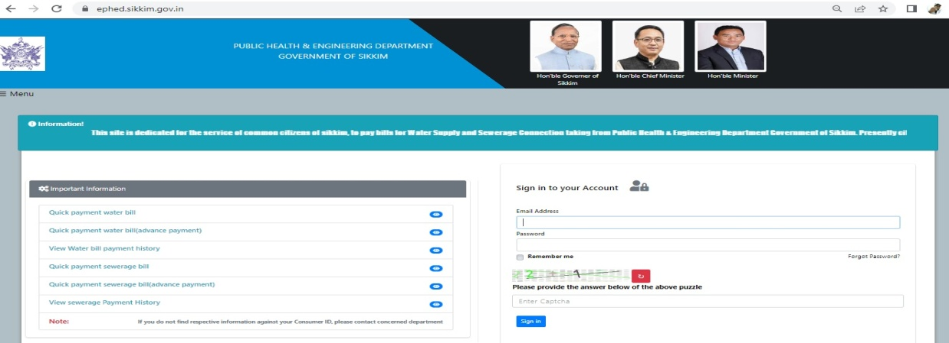
- Select on any one of above options Quick Payment for Water Bill, Advance Bill or Payment, similarly for Sewerage Bill.

- After selecting any one of the above mention options enter your consumer ID and Captcha number.
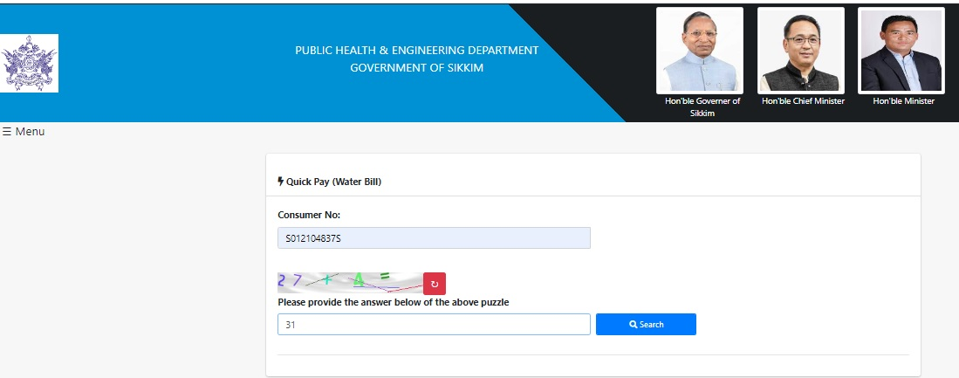
- After entering both Consumer number and Captcha this page will appear
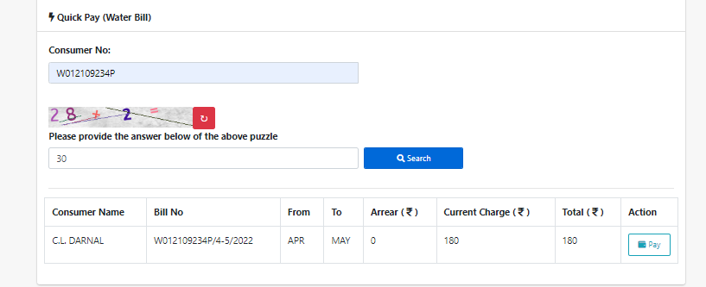

- Click on Pay Option this page will appear
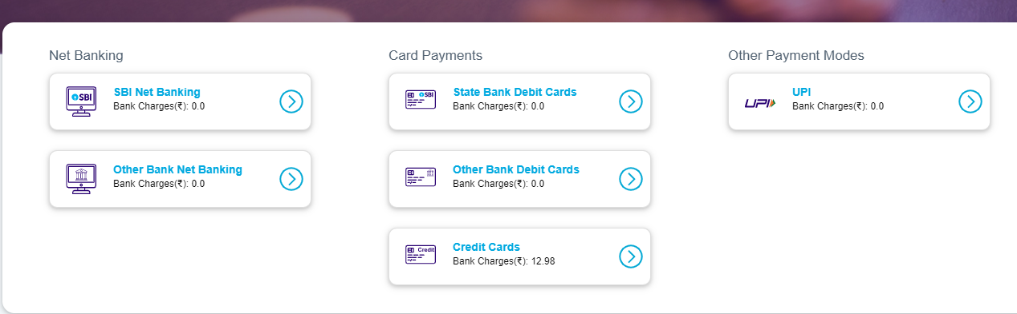
This is the payment options you can pay from any one of these payment methods.
Vii) After paying online this page will appear 