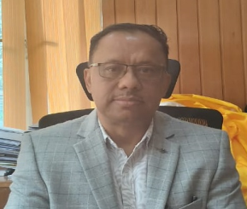

**Secretary’s Message**

Public Health Engineering Department, Government of Sikkim is primarily responsible for the essential service of providing clean potable water supply & proper sanitation in the entire urban town Rural Marketing Centre in the State of Sikkim.

The Department initially started functioning with two numbers of Divisions with limited staff, i.e. Water supply & Sewerage Divisions. Subsequently, due to increase volume of workload more Divisions, namely the North Division, East division, South Division, West Divisions and Planning  Division and Gangtok Water supply Division were created. The Water Security & Public Health Engineering Department under the Government of Sikkim is headed by the Principal Chief Engineer Cum Secretary, assisted by the Chief Engineer and other host of technical, administrative and Accounts officials.

The Government of Sikkim through the Department aims to provide the basic amenities to the people by providing potable and adequate drinking water supply and improving environmental hygiene by proper sanitation. The department undertakes planning, execution, operation and maintenance of water supply and sanitation works.

Large centralized Sewage Treatment Plant involves a very large wastewater collection system comprising of long gravity sewers, number of Intermediate sewage collecting stations, rising mains etc. which need large investment in capital and operation and maintenance of the system. In order to avoid such large sewerage and sewage treatment system, it has been planned to set-up in phased manner. Decentralized Mini STPs being set up under the entire urban towns and Rural Marketing centers in the state of Sikkim.

**PHE Department will be guided by the following services:**

1. Continuous endeavor to improve quality of service.
2. Supply the standard drinking water to urban town and Rural Marketing centers.
3. With the available resources, supply the water to the maximum quantity possible.
4. Providing efficient and adequate sewerage services in the urban towns in the State of Sikkim.
5. Infusion of concepts and practices of sanitation in the urban towns, and Rural Marketing centers.

**Mission:**

Providing safe, potable and sufficient water for all users which include private and government establishment and institution, all over the state. Providing efficient and adequate sewerage services in the state. Adopting strategies that take environmental concern into account while planning, leading to a pollution free environment. Providing effective services, easily available to everyone and also clear and effective communication with the citizen

**Chetraj Mishra**

**Principal Chief Engineer- Cum- Secretary**

**PHE Department  
 Government of Sikkim**